Z1 (computer)

[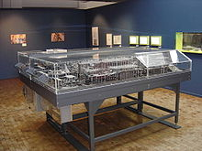](https://en.wikipedia.org/wiki/File:Zuse_Z1-2.jpg)

Replica of the Z1 in the German Museum of Technology In Berlin

Sumber : <https://en.wikipedia.org/wiki/Z1_(computer)>

The **Z1** was a mechanical [computer](https://en.wikipedia.org/wiki/Computer) designed by [Konrad Zuse](https://en.wikipedia.org/wiki/Konrad_Zuse" \o "Konrad Zuse) from 1935 to 1936 and built by him from 1936 to 1938. It was a binary electrically driven mechanical calculator with limited programmability, reading instructions from punched celluloid film.

The Z1 was the first freely programmable computer in the world which used [Boolean logic](https://en.wikipedia.org/wiki/Boolean_logic) and binary [floating point numbers](https://en.wikipedia.org/wiki/Floating_point_numbers), however it was unreliable in operation. It was completed in 1938 and financed completely from private funds. This computer was destroyed in the bombardment of Berlin in December 1943, during [World War II](https://en.wikipedia.org/wiki/World_War_II), together with all construction plans.

The Z1 was the first in a series of computers that Zuse designed. Its original name was "V1" for VersuchsModell 1 (meaning Experimental Model 1). After WW2, it was renamed "Z1" to differentiate from the [flying bombs](https://en.wikipedia.org/wiki/V-1_flying_bomb) designed by [Robert Lusser](https://en.wikipedia.org/wiki/Robert_Lusser). The [Z2](https://en.wikipedia.org/wiki/Z2_(computer)) and [Z3](https://en.wikipedia.org/wiki/Z3_(computer)) were follow-ups based on many of the same ideas as the Z1.

# Z2 (computer)

[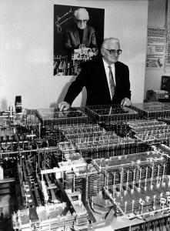](https://duniakkpi.files.wordpress.com/2011/07/zuse-z22.jpg)

Z2 Replica in German Museum of Techonology in Berlin

Sumber : http://ekateddytkj2.blogspot.co.id/2015/09/komputer-z3.html

The **Z2** was a mechanical and relay [computer](https://en.wikipedia.org/wiki/Computer) created by [Konrad Zuse](https://en.wikipedia.org/wiki/Konrad_Zuse" \o "Konrad Zuse) in 1939. It was an improvement on the [Z1](https://en.wikipedia.org/wiki/Z1_(computer)), using the same mechanical [memory](https://en.wikipedia.org/wiki/Computer_memory) but replacing the arithmetic and control logic with electrical [relay](https://en.wikipedia.org/wiki/Relay) circuits. Photographs and plans for the Z2 were destroyed by the [Allied bombing](https://en.wikipedia.org/wiki/Allied_bombing_of_Germany) during [World War II](https://en.wikipedia.org/wiki/World_War_II). In contrast to the Z1, the Z2 used 16-bit [fixed-point arithmetic](https://en.wikipedia.org/wiki/Fixed-point_arithmetic) instead of 22-bit [floating point](https://en.wikipedia.org/wiki/Floating_point).

Z3 (computer)

[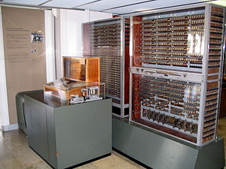](https://en.wikipedia.org/wiki/File:Z3_Deutsches_Museum.JPG)

Z3 Replica on display at Deutches Museum in Munich

Sumber : https://en.wikipedia.org/wiki/Z3_(computer)

The **Z3** was an [electromechanical](https://en.wikipedia.org/wiki/Electromechanical) [computer](https://en.wikipedia.org/wiki/Computer) designed by [Konrad Zuse](https://en.wikipedia.org/wiki/Konrad_Zuse" \o "Konrad Zuse). It was the world's first working [programmable](https://en.wikipedia.org/wiki/Computer_programming), fully automatic digital computer. The Z3 was built with 2,000 [relays](https://en.wikipedia.org/wiki/Relay), implementing a 22-[bit](https://en.wikipedia.org/wiki/Bit) [word](https://en.wikipedia.org/wiki/Word_(data_type)) length that operated at a [clock frequency](https://en.wikipedia.org/wiki/Clock_frequency) of about 5–10 [Hz](https://en.wikipedia.org/wiki/Hertz). Program code and constant data were stored on punched [film](https://en.wikipedia.org/wiki/Celluloid).

The Z3 was completed in [Berlin](https://en.wikipedia.org/wiki/Berlin) in 1941. The [German Aircraft Research Institute](https://en.wikipedia.org/wiki/German_Aerospace_Center) used it to perform statistical analyses of [wing flutter](https://en.wikipedia.org/wiki/Wing_flutter). Zuse asked the German government for funding to replace the relays with fully electronic switches, but funding was denied during [World War II](https://en.wikipedia.org/wiki/World_War_II) since such development was deemed "not war-important". The original Z3 was destroyed in 1943 during an [Allied bombardment of Berlin](https://en.wikipedia.org/wiki/Bombing_of_Berlin_during_World_War_II). The Z3 was originally called V3 (*Versuchsmodell 3* or Experimental Model 3) but was renamed to not be confused with Germany's [V-weapons](https://en.wikipedia.org/wiki/V-weapons). A fully functioning replica was built in the 1960s by Zuse's company, Zuse [KG](https://en.wikipedia.org/wiki/Kommanditgesellschaft), and is on permanent display at [Deutsches Museum](https://en.wikipedia.org/wiki/Deutsches_Museum" \o "Deutsches Museum) in [Munich](https://en.wikipedia.org/wiki/Munich). The Z3 was demonstrated in 1998 to be, in principle, [Turing-complete](https://en.wikipedia.org/wiki/Turing-complete).

Z4 (computer)

[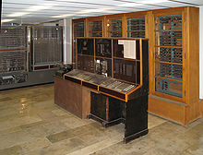](https://en.wikipedia.org/wiki/File:Zuse-Z4-Totale_deutsches-museum.jpg)

Z4 on display at the Deutches Museum, Munich

Sumber : <https://en.wikipedia.org/wiki/Z4_(computer)>

The **Z4** was the world's first commercial [digital computer](https://en.wikipedia.org/wiki/Digital_computer), designed by German engineer [Konrad Zuse](https://en.wikipedia.org/wiki/Konrad_Zuse" \o "Konrad Zuse) and built by his company *Zuse Apparatebau* between 1942 and 1945. The Z4 was Zuse's final target for the [Z3](https://en.wikipedia.org/wiki/Z3_(computer)) design, and like it, was an [electromechanical](https://en.wikipedia.org/wiki/Electromechanics) machine.

# Z5 (computer)

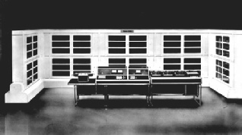

Z5(Computer)

Sumber : http://www.horst-zuse.homepage.t-online.de/z5.html

The **Z5** was a [computer](https://en.wikipedia.org/wiki/Computer) designed by [Konrad Zuse](https://en.wikipedia.org/wiki/Konrad_Zuse" \o "Konrad Zuse) and manufactured by Zuse KG following an order by Leitz GMBH in Wetzlar AG in 1950. The computer was delivered in July 1953 and was the first commercial built-to-order mainframe in Germany. The computer was purchased to help with the design of optical lens systems.

The Z5 is the successor of the Z4, and is much more compact and powerful. Zuse implemented the machine with relays, since [vacuum tubes](https://en.wikipedia.org/wiki/Vacuum_tube) were too unreliable at the time. The Z5 used the same principles as the [Z4](https://en.wikipedia.org/wiki/Z4_(computer)), but was six times faster. It also had [punched tape](https://en.wikipedia.org/wiki/Punched_tape) readers, which the Z4 did not have. It had conditional branching and five subroutine loops.